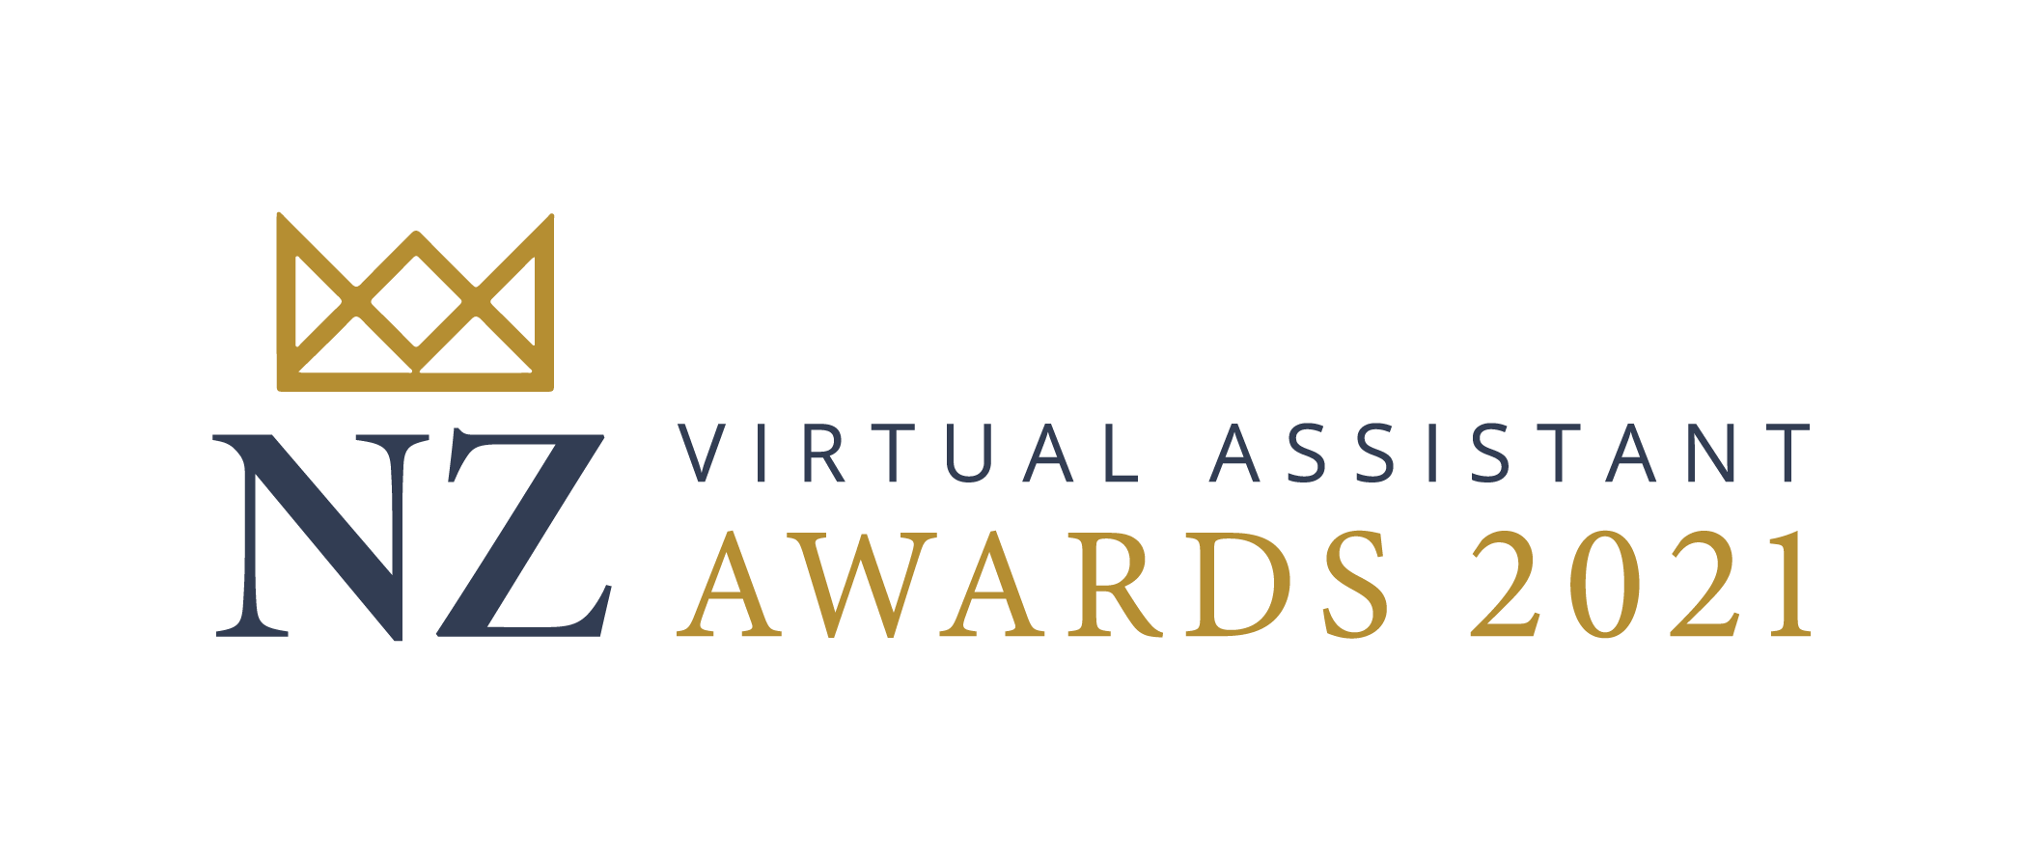
2021 NZ Virtual Assistant Awards

Entry Form - Best Virtual Assistant Website

Thank you for taking the time to enter the 2021 Virtual Assistant Awards. This is the first in many years of recognising the hard work and dedication that Virtual Assistants provide to New Zealand businesses.

The Best VA Website Award recognises the most outstanding Virtual Assistant website of the year, taking into account beautiful design, great functionality, content that converts and exceptional SEO.

Please note that while we are looking for the best VA website, it does not have to have been designed or written by yourself, provided you have had input into both.

The website must be your own Virtual Assistant business website, not a website you have created for a client.

To enter this award you must be a current Bronze, Silver or Gold member of the Virtual Assistant Network of NZ

Timeline
Entries Open: 14 June
Entries Close: 5 July
Judging Commences: 9 July
Finalists Announced: 6 August
Awards Evening: 25 September

Contact Details
Name:
Phone:
Email Address:
Physical Address:

Business Details
Business Name (this will be how it appears on the Award):
Your Position:
Date Business Founded:

Entry Questions

What is your virtual assistant business website URL?

Describe the process that you undertook to develop your website including who was involved.
250 words max

Show us how your website has performed over the last 12 months and how your website has helped your business? Feel free to include screenshots, stats, graphs etc.
250 words max

How do you actively manage your website’s SEO and improve its overall performance?
250 words max

Please complete this entry form, save it using your business name and Best VA Website in the file name, and email it to us at support@savvyschool.co.nz before 12noon Monday 5 July 2021.

By entering these awards and submitting your entry, you confirm that you have read and understood the General Conditions of Entry and those applying to the particular category you have entered, and you agree to comply with these.

General Conditions of Entry

The NZ Virtual Assistant Awards are open to eligible virtual assistants who hold a current Bronze, Silver or Gold membership at the Virtual Assistant Network of New Zealand. The Awards are organised by the Virtual Assistant Network of New Zealand and Savvy School.
- Award category entries are for a number of finalists and one winner
- Each entry shall be certified at the time of submission as being accurate and complete by a designated authority
- All entries and supporting material must be received by the Savvy School by 12 noon Monday 5 July 2021. All entries are to be submitted electronically to support@savvyschool.co.nz marked with “Virtual Assistant Awards Entry” in the subject
- Entries should include a high-resolution copy of the applicant’s logo and a headshot as a JPEG or PNG file (where applicable) and the organisers have permission to use this logo and headshot in association with the event
- Entry forms should be submitted as a PDF file no larger than 5 Mb
- Entries may include supporting material such as graphs, charts, photographs, tables or links to websites. Please do not include any promotional material, such as corporate brochures or sales literature
- The organisers reserve the right to publish information contained in the entry at the time finalists and winners are announced. Information that entrants do not wish to have published must clearly be marked as confidential.
- The organisers reserve the right to publish finalists and winners details and images for marketing and promotional purposes.
- Organisations, groups or individuals can enter more than one award category (where applicable), however separate entry forms must be completed in full and submitted for each.
- Where third parties or other organisations are mentioned in entries, the submitter must describe the relationship and seek the third party’s permission to reference them.
- If an entrant is selected as a finalist, the entrant (or designated representative) agrees to attend the formal awards presentation at the nominated venue in Hamilton or online on Saturday 25 September 2021 and meet any costs of attending.
- The judges have the discretion not to grant an award if none of the entries are considered of a sufficient standard.
- If any judge declares a possible conflict of interest with any of the entries, they will withdraw from assessing that particular entry.
- The judges reserve the right to request further information or clarification after the entry has been submitted.
- The judges undertake to observe the confidentially of entries where required
- The entrant accepts that the judges’ decision is final and that no subsequent correspondence will be entered into.
- A secure electronic copy of your entry will be kept for the NZ Virtual Assistant Awards records until after the Awards event.
- Finalists will be notified on Friday 6 August 2021.

